Project name:

**3D CAR GAME**

الاسم:محمد فتحى محمد محمد ابوالنجا.

الاسم:محمد متولى مصطفى متولى.

الاسم:محمد محمود عبدالتسار حسن لاشين.

الاسم:محمد عصام مسعد عبدالمنعم.

الاسم:عبدالرحمن ياسر السيد سالم.

تحت اشراف:

د/رشا عريان . م/مي أشرف.

Introduction:

The idea of ​​the project is a 3D car game.

-The car is driven by keyboard or mouse.

- When the car runs between the barriers, a score is calculated for it.

- When the car crashes into the barrier, the player loses, and he has to choose to play again or leave, and the score that he reached before the collision is calculated for him.

There are types of barriers, some of which are fixed in place / or movable on the X axis.

- It is located in the finish line, upon reaching it, the player wins and the full score is calculated for him.

To start game :Clik on the button “s”

To move to right :

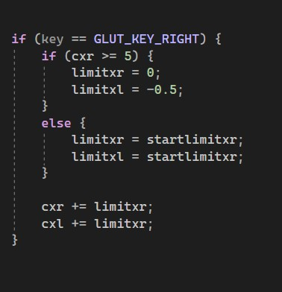

To move to Left :

